**DOCUMENTATION:**

**I) Requirements Document**

**II)Testing Document**

**III) User manual**

**Venn Diagram Builder Report**

*Group 15: Warsame Osman 215551914 , Jada Jones 215562044 , Parssa Khazra 216147936 , Brian Dang 216509408*

*Client Needs***:**

* A program that creates a customizable venn diagram
* A program that enables you to create your venn diagram template of choice
* The venn diagram needs to have the option of selecting 2 or 3 regions
* The venn diagram needs to have the option of selecting the intersections of the regions
* The venn diagram needs to be able to insert text into these regions
* The venn diagram needs to be exported through multiple platforms(pdf, png,jpeg)

*Use Cases:*

The functionality of our program provides many cases towards the orientation of the Venn diagram.

Press create new Venn Diagram button to open the Venn diagram builder form

* + Select 3 regions from the drop down menu
    - Select up to three intersection choices for a three region spaced diagram
  + Select 2 regions from the drop down menu
    - Select the intersection for a classic Venn diagram, press done

*Acceptance Test Cases:*

***Two region venn diagram:***

Select “2” regions from the drop down menu

* + Choose to select no intersection
  + No generated venn diagram, please exit application by first exiting the venn builder form window, then the larger window titled “ venn diagram maker”. Both have exit buttons on the top right of their windows.

Select “2” regions from the drop down menu

* + select “S1 intersect S2” checkbox
  + Generated venn diagram preview, press the “done” button on the bottom right. A venn diagram is generated.

***Three region venn diagram:***

Select “3” regions from the drop down menu

* + Only one or less intersection chosen
  + No generated venn diagram, please exit application by first exiting the venn builder form, then the larger window titled “ venn diagram maker”. Both have exit buttons on the top right of their windows

Select “3” regions from the drop down menu

* + Select “S1 intersects S3” and “S1 intersects S2”
  + Generated venn diagram preview, press the “done” button on the bottom right. A venn diagram is generated.

Select “3” regions from the drop down menu

* + Select “S1 intersects S3” and “S2 intersects S3”
  + Generated venn diagram preview, press the “done” button on the bottom right. A venn diagram is generated.

Select “3” regions from the drop down menu

* + Select “S1 intersects S2” and “S2 intersects S3”
  + Generated venn diagram preview, press the “done” button on the bottom right. A venn diagram is generated.

Select “3” regions from the drop down menu

* + Select “S1 intersects S2” and “S1 intersects S3”
  + Generated venn diagram preview, press the “done” button on the bottom right. A venn diagram is generated.

*Testing*

***Test Cases Run:***

The test cases run similarly based on limited actions within the creation of the venn diagram but really spread apart from how much more options become available. Upon creating the venn diagram the user is met with listed options for themselves. Selecting either 2 or 3 regions will pop open a preview with all checks already selected for the users. From preference the user may decide on deselecting some checks and the preview changes based on the selection. If the user deselects them all, the creation cannot be completed. If the user wishes to close the creation window, he/she may do so and is still capable of reopening the window from the start up. Each version of the venn diagram that can be created works as intended within the test cases.

Then there includes the testing for adding the information to the venn diagram. This includes: inputting the different blocks (which are seperated with an enter key), converting the text blocks into movable blocks and moving the blocks to the venn diagram. Starting off light, inputting short and small numbers of text work quite well when converting them to moving blocks. Dragging them to the venn diagram works as intended. There lies an issue when it comes to going to bigger extremes with the test cases. Longer sentences and such don’t fit and are not readable to the user when converted to moving blocks. Converting a mass number of text blocks to moving blocks isn’t possible as some are not converted in the end. Lastly, adding too much to the venn diagram proves problematic when space becomes an apparent issue.

***Test Cases Derive & Implement:***

The test cases were derived from expectations on what the client requested. From the previous meetings there were several requests and improvements to what the clients wanted within the program. Such improvements included quality of life additions within the creation menu of the venn diagrams: where the user is still able to decide on the number of colliding circles but the preview is changed to see available options first and further deselecting to preference. Handling the cases of how the text options were added to the venn diagram were also included in the clients request. Upon looking at the client’s request there was an additional requirement for handling odd cases. Due to the freedom of adding text options to the venn diagram, there needed to be insurance that it could run well from mass loads as well as little.

***Reasonings for Sufficient Testings:***

The reasoning that this is sufficient testing for the program is because the client can have a very open ended experience. The program enables the ability to be freely used for a multitude of purposes and is made to be extremely easy to use. The test cases were made to represent that. A major note that is in mind is how easy it would be for a child to use the program without even knowing what it is. We’ve decided that these test cases are sufficient because it covers most of the features that we wanted to have included in the end product.

***Testing Metrics:***

The test coverage shows that the program runs with all the implementations. What’s missing is a method to trace back steps and include the different venn diagram variations in the same instance of the program. Running through each variation will cover the entirety of the code.

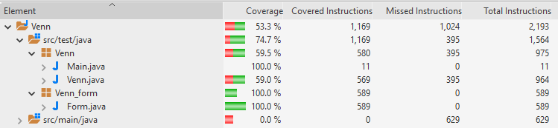

Prototype Create Phase

User Manual

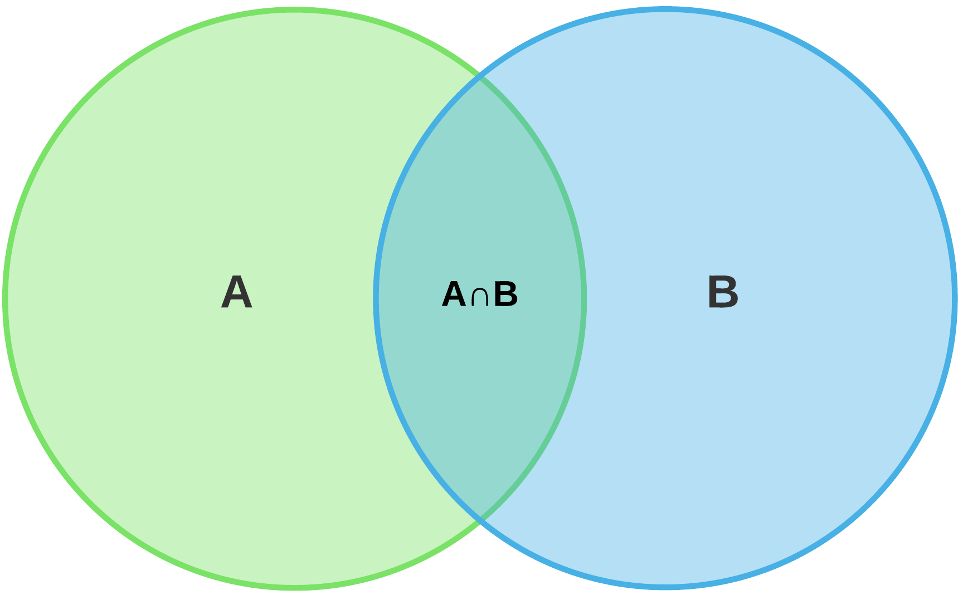

*Product Name – VennSmarter*

*Group 15:*

*Warsame Osman 215551914*

*Jada Jones 215562044*

*Parssa Khazra 216147936*

*Brian Dang 216509408*

**Installation and user instructions:**

How to get started:

1. Download the executable jar file from the provided link: https://drive.google.com/file/d/1iROWpQtTuml5Y6F4F4sHq0NrHiehXDUj/view?usp=sharing
2. Once the program is downloaded, run it through the command line with the following command: java -jar venn_prototype.jar (make sure you are in the same directory.

How to create a Venn Diagram:

1)Open the folder “Venn”, then open the folder “src/test/java”.

2)Go to the package Venn in that folder, right click on “Main.java”.

3) Scroll down to “run as”, and click “Java application”.

4) A large window appears with a button in the centre named “Create a Venn Diagram”, click that button.

5) A new window appears with a title “number of regions” and a drop down menu on to its right.Click on the drop down menu.

6) The prompt text of the drop down menu reads “select a value”. It gives us two options “2” for two regions and “3” for regions. Select “3”.

7) Three checkboxes appear with labels “ s1 intersect s2”, “s1 intersect s3” and “s2 intersect s3”. **You must pick at least two out of three** options for the venn diagram to be configured successfully. Select “s1 intersect s2”and “s1 intersect s3”.

8) Click the done button on the bottom of the window.The window will exit and you will be left with a window with the desired venn diagram, and a button named “add a text box” on the bottom right.

9)Click on the “add a text box” button once. A textbox is created.

10) Double click on the textbox. A small window appears titled “set text”, underneath it is a textarea for you to type what you want to display in that textbox,type “hello there” and press “ok”.

11) This textbox can be moved along the window and into the venn diagram on the left by dragging it with your mouse.

12) Now you have successfully created your very own Venn diagram , with this product VennSmart.

13) To exit,click on the top right exit button.

General case scenario





